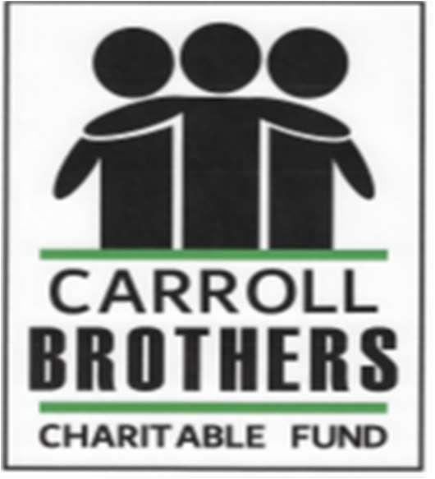
CARROLL BROTHERS CHARITABLE FUND
ASSISTANCE APPLICATION

Assistance shall be provided based on family/individual needs determined after review by the Carroll Brothers Charitable Fund Review Committee. To be eligible for financial assistance from the Carroll Brothers Charitable Fund, an individual or family must meet all of the requirements of the below Eligibility Requirements for Families/Individuals Receiving Charitable Assistance.
Eligibility Requirements:

Preferences will be given to Individuals/Families who reside or have resided within the local area of the foundation.

Individual/Family must provide documents showing financial hardship due to medical expenses, natural disaster or fire.

Individual/Family must not have received financial aid from the charity in the past 12 months.

Individual/Family is presently being treated or recently completed treatment for cancer or other devastating disease or is recovering from a natural disaster or fire, as determined by the Review Committee

Individual/Family must use funds for essential needs only, such as (but not limited to):

- Rent/Mortgage
- Childcare
- Utilities
- Food
- Medical Bills
- Transportation

Documents must be provided. A photocopy of Illinois Driver’s License or State ID. A parent or guardian must submit a photocopy of their Illinois Driver’s License.

The recipient must not be related by blood or marriage to any board members.

Please return the completed application to:
E-mail: carrollbrothersfund@gmail.com
Mail: P.O. Box 4, Chicago Ridge, IL 60415
www.carrollbros.org

PERSONAL INFORMATION:
Application Date: _____ /_____ /________
Name of Patient: __________________________________________________________________
Name of Legal Guardian (if submitting on behalf of minor): __________________________________
Address: __________________________________________________________________________
City: ___________________________ State: _________________ Zip Code: __________________
Phone Number: ___________________________________
Email Address: __________________________________ Date of Birth: ______/______/__________
Driver’s License / State I.D. # ________________________ SSN: ____________________________
What grammar school and/or high school are you and your family affiliated with: ________________
__________________________________________________________________________________
Names and Ages of all Household Members (including Patient):
__________________________________________________________________________________
__________________________________________________________________________________
__________________________________________________________________________________
__________________________________________________________________________________

MEDICAL INFORMATION:
Diagnosis: ________________________________________________________________________
Date of Diagnosis: ______/______/________
Hospital / Facility of Treatment: _______________________________________________________
Name of Physician, Nurse Practitioner or Social Worker: ____________________________________
Signature of one of the above: _________________________________________________________

HEALTH INSURANCE INFORMATION:
Do you have health insurance? Yes / No
If not covered, have you applied for Medicaid? Yes / No
Do you pay for your health insurance monthly? Yes / No
If yes, amount $ __________________
Please indicate types of insurance (circle all that apply)
Medicaid Medicare only Private Insurance Cobra
Medicaid + Medicare Medicaid + Supplemental Insurance
Other (please specify): _______________________________________________________________

FINANCIAL INFORMATION:
Current Employment Status? Employed Unemployed Retired Disabled
If unemployed, what was your last date worked? ______/______/_________
Are you receiving unemployment benefits? Yes / No
If disabled, are you receiving disability? Yes / No
If yes, what type of disability (i.e., short-term, long-term, social security, private policy, etc.)
_______________________________________________________________________________
What was your household gross income in the last calendar year? $ ________________________
What is your anticipated household gross income this year? $_____________________________
We require the following financial documents:
Please submit ONE of the following types of information relating to income verification for your household:
• Two most recent paystubs and/or social security and pension statements
• Copies of your last two federal tax returns
• Bank statements (previous two months)
Are you past due on any household bills (mortgage, rent, car, tuition, utilities, etc.? Yes / No
If yes, please let us know (please note proof may be requested): _____________________________
________________________________________________________________________________
________________________________________________________________________________
What is your largest financial concern during this difficult time?_____________________________
________________________________________________________________________________
________________________________________________________________________________
________________________________________________________________________________

If you wish to attach a short summary of your story for us to better understand your situation. Please keep to one page. This is not a requirement.

APPLICANT DECLARATION AND RELEASE FORM
I verify that the information provided in my application is complete, accurate, and true. I further
understand that reported financial information may be verified by the Carroll Brothers Charitable Fund.

Printed Name: _________________________________________ Date: ______/______/________

Signature: _____________________________________________Phone: (____) ______________

Address: ________________________________________________________________________

City: _____________________________ State: ____________________ Zip Code: ___________

If the person is under the age of 18:

I, ____________________________________am the parent/guardian of the individual named above.
Printed Name: _________________________________________ Date: ______/______/________

Signature: _____________________________________________Phone: (____) _______________

Address: _________________________________________________________________________

City: _____________________________ State: ____________________ Zip Code: ____________

Please return the completed application to:
E-mail: carrollbrothersfund@gmail.com
Mail: P.O. Box 4, Chicago Ridge, IL 60415

For more information on the Carrol Brothers Charitable Fund please visit our website at:
www.carrollbros.org

____________________________________________________________________________________________

TO BE COMPLETED BY CARROLL BROTHERS CHARITABLE FUND REVIEW COMMITTEE:

APPROVED REJECTED
AMOUNT OF ASSISTANCE PROVIDED: $_____________________________________________
CHECK MADE PAYABLE TO: _______________________________________________________
DATE: _______/________/__________

